Belly Fat Burning Brownies  
Servings: 8  
  
[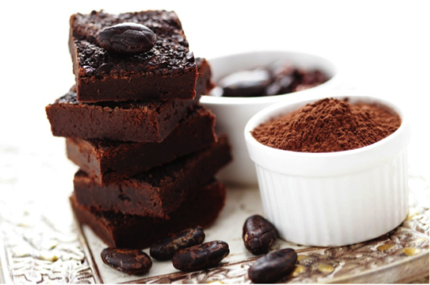](http://etrmailbox.com/iem/link.php?M=222152&N=748&L=694&F=H)   
  
Ingredients  
  
* 1 cup cooked black beans (organic if possible)  
* 1 1/2 large eggs  
* 1 tbsp + 2 tsp extra virgin olive oil  
* 2 tbsp cocoa powder  
* 1/3 cup soaked pitted dates, finely chopped (about 12-14)  
* 1/2 tsp baking soda  
* 1/2 tsp apple cider vinegar  
* 1/8 tsp sea salt  
* 1/2 tsp pure vanilla extract  
* 2-3 tbsp dark chocolate chips  
  
Directions  
  
1. Soak dates for 1-2 hours until soft, but not mushy, drain and chop finely  
2. Preheat oven to 350F  
3. Rinse and drain the black beans well  
4. Add all ingredients except for chocolate chips in blender and blend until very smooth  
5. Stir in chocolate chips   
6. Pour batter into rectangular loaf pan that has been brushed with butter or olive oil or lined with parchment paper  
7. Bake at 350F for 20-25 minutes, do not overcook  
8. Brownies are ready when a toothpick inserted into the middle comes out clean  
9. Cool and then cut into squares  
  
TIP: These taste even BETTER after a night in the fridge,   
but I don't blame you for having one while they're still hot. :)